**ASSIGNMENT_2**

**IBM Watson IOT platform:**

It’s a fully managed, cloud-hosted service with capabilities for device registration, connectivity, control, rapid visualization and data storage.

It is designed to make it simple to derive value from your Internet of Things devices. STMicroelectronics is an IBM Partner and provides development platforms allowing users to develop applications with direct connection to the IBM Watson IoT platform.

* **Device Management**

Using this device management service, we can perform device actions like rebooting or updating firmware, receive device diagnostics and metadata, or perform bulk device addition and removal.

* **Responsive, scalable connectivity**

In this we use the industry-standard MQTT protocol (OASIS ratified) to connect devices and applications. MQTT is designed for efficient exchange of data to and from devices in real-time.

* **Secure Communication**

Securely receive data from and send commands to your devices. Do this using MQTT with TLS to secure all communication between your devices and our service.

* **Data lifecycle management**

As well as having access to real-time data coming from our devices, we can optimize to store data for a period of our choice, allowing us to have access to historical and real-time data for our devices.

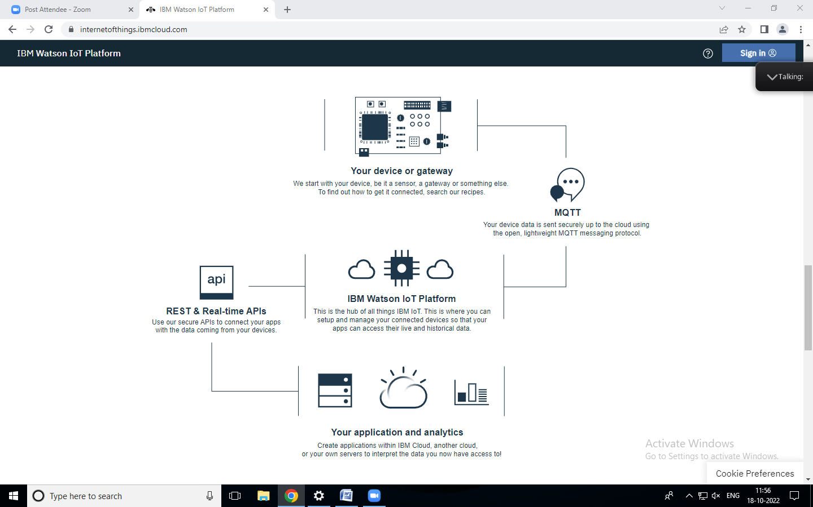

**Node RED Service:**

Node-RED is a programming tool for wiring together hardware devices, APIs and online services in new and interesting ways. It provides a browser-based editor that makes it easy to wire together flows using the wide range of nodes in the palette that can be deployed to its runtime in a single-click.

### Browser-based flow editing

Node-RED provides a browser-based flow editor that makes it easy to wire together flows using the wide range of nodes in the palette. Flows can be then deployed to the runtime in a single-click. JavaScript functions can be created within the editor using a rich text editor. A built-in library allows us to save useful functions, templates or flows for re-use.

### Built on Node.js

The light-weight runtime is built on Node.js, taking full advantage of its event-driven, non-blocking model. This makes it ideal to run at the edge of the network on low-cost hardware such as the Raspberry Pi as well as in the cloud. With over 225,000 modules in Node's package repository, it is easy to extend the range of palette nodes to add new capabilities.

### Social Development

The flows created in Node-RED are stored using JSON which can be easily imported and exported for sharing with others. An online flow library allows us to share our best flows with the world.